1. Click on Get Data and select SQL server

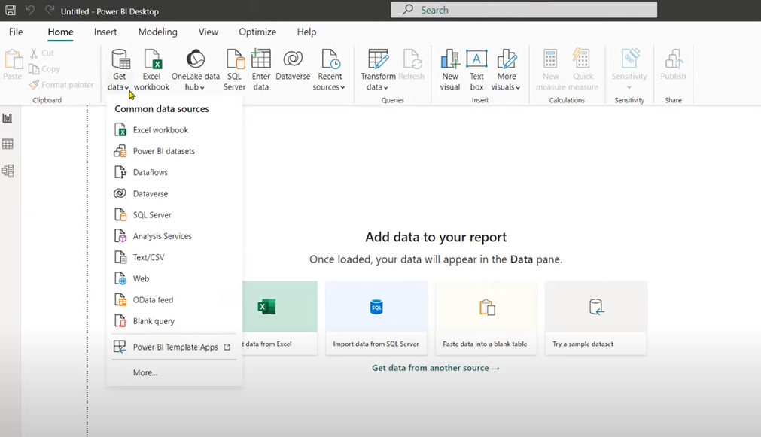

1. Enter the Server name and click ok

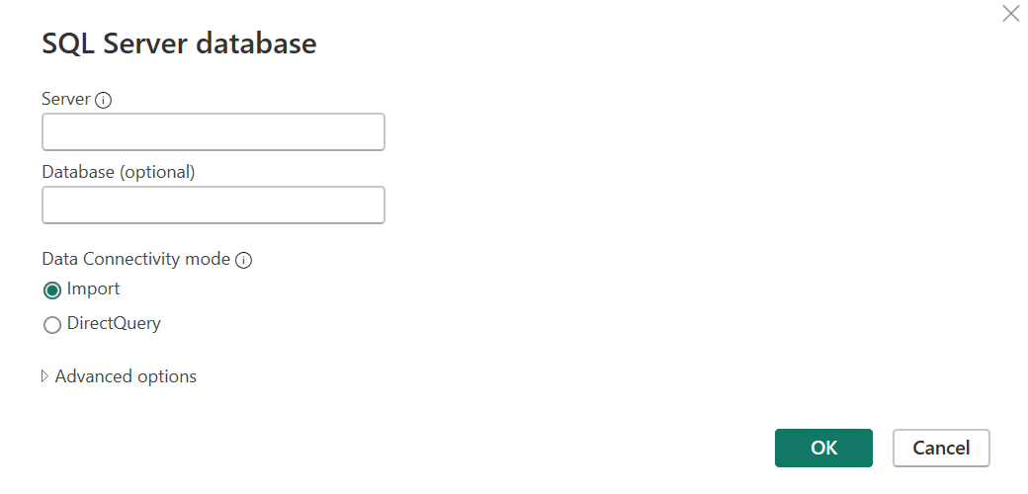

1. Select the intended database and select the tables required and click on load /transform

